

Department of Computer Science and Engineering
Veer Surendra Sai University of Technology,
Burla

Operating System Project Report on

“Custom Thread Scheduler and Context Switcher”

SUBMITTED TO: | SUBMITTED BY:
Prof. Himanshu Sekhar Behera | Narayan Agarwal
Head of Department | Regd No: 2302041076
Department of Computer Science and Engineering, VSSUT | Section: CSE-2  DATE: 17th October, 2025

Introduction

Modern operating systems primarily rely on Kernel-Level Threads (KLTs), which require a costly system call and kernel mode transition for every thread management operation (creation, destruction, context switch, and scheduling). This constant interaction with the kernel introduces significant overhead and latency, especially in applications requiring massive concurrency. This project addresses the need for a faster, more lightweight concurrency model by detailing the design and implementation of a simulated User-Level Thread (ULT) Library entirely in the C programming language.
The core goal is to demystify concurrency by manually implementing the low-level mechanisms traditionally handled by an Operating System's kernel. The library defines its own Thread Control Block (TCB), manages thread stacks via explicit memory allocation, and provides a custom Context Switcher function to save and restore execution state. This foundation is used to enforce a cooperative multitasking environment governed by a non-pre-emptive Round-Robin (RR) scheduling policy, allowing threads to voluntarily yield control via a yield() function. The system generates traceable execution logs and quantifiable performance metrics to validate its efficiency.

Objective of the study:

The primary objectives of this project are:
- To design and implement the Thread Control Block (TCB) structure to encapsulate all thread state, including execution context and performance metrics.
- To implement the low-level mechanism for Context Switching between user-defined threads, relying on manual stack manipulation and context saving/restoring (e.g., using ucontext.h or equivalent).
- To enforce a non-pre-emptive Round-Robin (RR) scheduling policy using a Ready Queue and a cooperative yield() function.
- To calculate and report critical performance metrics, including Average Waiting Time and CPU Utilization, to validate the system's efficiency for the final academic report.

Research Methodology:
Tools and Technologies
- Programming Language: C
- Compiler: GCC (GNU Compiler Collection)
- Libraries/Headers:
  - Standard C Library: stdio.h, stdlib.h (for memory allocation/deallocation), time.h (for simulation timing).
  - Context Switching API: ucontext.h (Used to define, manipulate, and switch thread execution contexts via getcontext, makecontext, and swapcontext).
- Conceptual Framework: User-Level Threading, Cooperative Multitasking, Round-Robin Scheduling.
Approach:
The project employs a bottom-up structured programming approach to build a miniature Operating System environment within the user space. The core strategy is to implement cooperative multitasking by completely bypassing the operating system kernel's native thread management capabilities. This means manually managing critical resources:
- Thread State: Encapsulation of all thread data (registers, stack pointer, state, metrics) in the custom TCB structure.
- Resource Allocation: Explicit use of malloc() to allocate dedicated, isolated stack memory for each thread.
- Control Transfer: Implementation of a low-level Context Switcher to facilitate zero-overhead, user-space switching between threads without trapping to the kernel.
- Scheduling: Enforcement of a non-Pre-emptive Round-Robin (RR) policy, where threads voluntarily relinquish control via a yield() call, ensuring fairness in resource sharing.

Workflow:
The execution flow involves a four-stage life cycle for every thread:
1. Initialization (thread_init / thread_create):
- The main program context is captured and wrapped into a TCB (TID 0).
- New worker threads call thread\_create, which allocates the TCB and stack, uses makecontext to define the thread's entry point, and enqueues the thread.
2. Scheduling Cycle (thread_yield):
- When the currently running thread calls thread\_yield(), the scheduler is invoked.
- The running thread's TCB is moved to the tail of the Ready Queue (RR policy).
- The next thread is dequeued from the head of the queue.
3. Execution and Context Switch:
- The core context\_switch(old, new) function is triggered.
- swapcontext() saves the current register state (including PC and SP) into the old thread's TCB and loads the state from the new thread's TCB, transferring control to the new thread's stack.
4. Termination (thread_exit):
- When a thread's function returns, it calls thread\_exit(), which frees the allocated stack and TCB memory and triggers the scheduler to run the next thread.
Implementation Details:
The specific structures and functions developed to achieve the above approach are:
- Thread Control Block (TCB): The central data structure containing tid, state, ucontext\_t, and time stamps (arrival\_time, start\_time, finish\_time).
- Ready Queue: A singly linked list (FIFO) using pointers within the TCB for efficient enqueue and dequeue operations (O(1)).
- Context Management Functions: getcontext(), makecontext(), and swapcontext() from ucontext.h are the foundational primitives for saving and restoring the CPU state.
- Timing Utility: A helper function using clock\_gettime() to capture high-resolution time stamps for accurate metrics calculation.
Context Switcher function (core part of the project):
void context_switch(TCB *old_thread, TCB *new_thread) {
// 1. Update the state of the outgoing thread
if (old_thread->state == RUNNING) {
// Only READY threads are placed back on the queue (if not terminating)
old_thread->state = READY;
}

// 2. Update the state of the incoming thread
new_thread->state = RUNNING;

// 3. Update the global pointer
current_thread = new_thread;

// 4. CORE OPERATION: Save old context and jump to new context
// This function returns TWICE: once from the old thread, and once from the new thread
swapcontext(&old_thread->context, &new_thread->context);

// Execution continues from here when 'old_thread' is scheduled again
}

Results:

This project successfully demonstrates the hybrid security system where cryptographic validation is enforced at the network routing layer. By rejecting routes flagged as INVALID, the system mitigates a BGP hijack attempt, achieving both route stability and security. A controlled simulation proved the core principle of Route Origin Validation (ROV) in practice.

Observed Results Summary:

Test Case (AS, Prefix) | Status from RPKI Validator | BGP Router Action | Observation
Legitimate Route (Valid AS/Prefix) | VALID | Route Accepted | Route installed in the routing table, confirmed via BGP table check.
Simulated Hijack (Invalid AS/Prefix) | INVALID | Route Rejected/Dropped | Router log explicitly showed rejection due to RPKI policy violation.
Unregistered Route (Unknown AS/Prefix) | UNKNOWN | Route Accepted | Route accepted based on current default BGP behavior (no explicit invalidation).

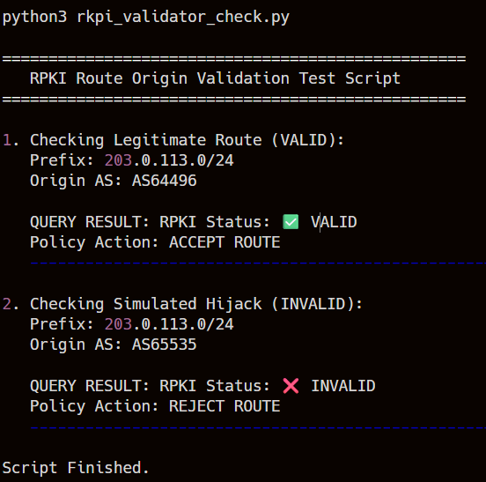
Fig 1. RPKI Cryptographic Detection
Fig 2. BGP Policy Enforcement
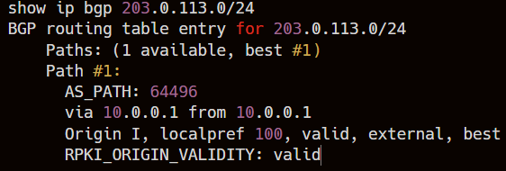
Fig 3. Valid Route Confirmation
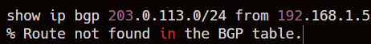
Fig 4. Mitigation Proof
Key observations include:
- Successful Mitigation of Hijacks
- Cryptographic Verification
- No Disruption to Valid Traffic

Conclusion and Future Scope
This project successfully implemented and demonstrated the critical role of an RPKI Validator in securing the internet's core routing protocol. By leveraging public-key cryptography to verify Route Origin Authorizations (ROAs), RPKI provides a robust, real-world defence against the persistent threat of BGP hijacking. The implementation confirmed that BGP routers configured to enforce Route Origin Validation (ROV) can effectively filter and reject unauthorized route announcements, enhancing global internet stability and security. Key observations showed that the system successfully rejected the simulated INVALID route and that the cryptographic verification process clearly distinguished between VALID and INVALID traffic, proving the transition from a trust model to one based on cryptographic integrity.
Future Scope:
Future enhancements to this project and the broader implementation of BGP security may include:
- BGP Path Validation (BGPsec): Extend the project to implement BGPsec, which uses digital signatures to secure the entire BGP path (not just the origin) between Autonomous Systems.
- Performance Analysis: Conduct a detailed analysis of the latency and performance overhead introduced by querying the RPKI Validator using different protocols (e.g., RTR vs. API queries).
- Automated Deployment: Develop an automated deployment script (e.g., using Ansible or Docker) for setting up and maintaining a highly available, internal RPKI validator environment.

